Lab Exercise - Azure Kubernetes Service (AKS) using Azure Cloud Shell

Objective
In this lab, you will:
- Create an AKS cluster
- Configure Kubernetes access
- Deploy containerized applications
- Expose applications using LoadBalancer
- Scale applications
- Verify Kubernetes resources
using Microsoft Azure Cloud Shell.

Lab Architecture
Azure Cloud Shell
|
v
Azure Kubernetes Service (AKS)
|
v
Kubernetes Deployment
|
v
LoadBalancer Service
|
v
Public Application Access

Prerequisites
- Azure Subscription
- Azure Cloud Shell access
- Basic Linux commands knowledge

Lab Environment
Resource | Value
Resource Group | rg-aks-hpa
AKS Cluster | aks-hpa-cluster
Node Count | 1
VM Size | Standard_B2s
Node Pool Name | agentpool
Region | centralindia

Step 1: Open Azure Cloud Shell
Open:
Azure Portal
Launch:
- Cloud Shell
- Select Bash

Step 2: Create Resource Group
az group create \
--name rg-aks-hpa \
--location centralindia

Step 3: Create AKS Cluster
Note: These values comply with the lab subscription policy restrictions.
az aks create \
--resource-group rg-aks-hpa \
--name aks-hpa-cluster \
--node-count 1 \
--node-vm-size Standard_B2s \
--nodepool-name agentpool \
--generate-ssh-keys

Deployment may take 5–10 minutes.

Step 4: Connect to AKS Cluster
az aks get-credentials \
--resource-group rg-aks-hpa \
--name aks-hpa-cluster

Expected Output:
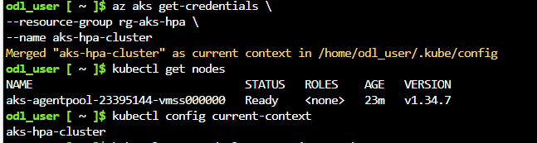
Step 5: Verify AKS Nodes
kubectl get nodes

Expected Output:
STATUS: Ready

Step 6: Verify Kubernetes System Pods
kubectl get pods -A

This shows all Kubernetes system components.

Step 7: Create NGINX Deployment
kubectl create deployment nginx-app \
--image=nginx

Step 8: Verify Deployment
kubectl get deployments

Step 9: Verify Pods
kubectl get pods

Expected Output:
Running

Step 10: Expose Deployment using LoadBalancer
kubectl expose deployment nginx-app \
--port=80 \
--type=LoadBalancer

Step 11: Verify Service
kubectl get svc

Wait for:
EXTERNAL-IP
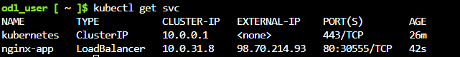
to appear.

Step 12: Access Application
Open browser:
http://EXTERNAL_IP

You should see the NGINX welcome page.
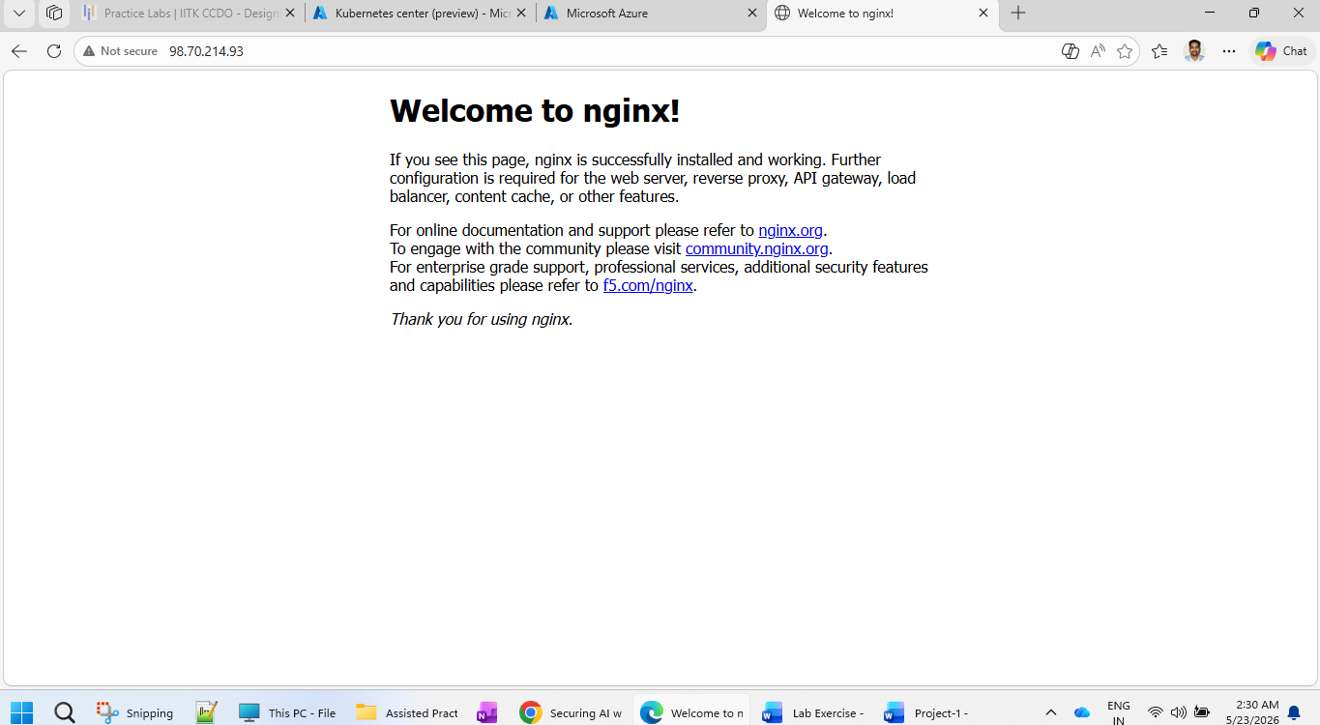

Step 13: Scale Deployment
Increase replicas:
kubectl scale deployment nginx-app \
--replicas=3

Step 14: Verify Scaling
kubectl get pods

Expected:
- 3 running pods

Step 15: Describe Deployment
kubectl describe deployment nginx-app

Step 16: View Cluster Information
kubectl cluster-info

Step 17: Delete Application Service
kubectl delete svc nginx-app

Step 18: Delete Deployment
kubectl delete deployment nginx-app

Step 19: Verify Cleanup
kubectl get all

Step 20: Delete AKS Cluster (Optional)
az aks delete \
--resource-group rg-aks-hpa \
--name aks-hpa-cluster \
--yes

Step 21: Delete Resource Group (Optional)
az group delete \
--name rg-aks-hpa \
--yes

Expected Outcome
After completing the lab:
- AKS cluster deployed successfully
- Kubernetes cluster connected using kubectl
- NGINX application deployed
- Application exposed using LoadBalancer
- Pods scaled successfully
- Kubernetes resources managed from Cloud Shell

